MASTER R WEEK 2 SUMMARY

###3.6.1 Exercises

####question2

ggplot(data = mpg, mapping = aes(x = displ, y = hwy, color = drv)) +

geom_point() +

geom_smooth(se = FALSE)

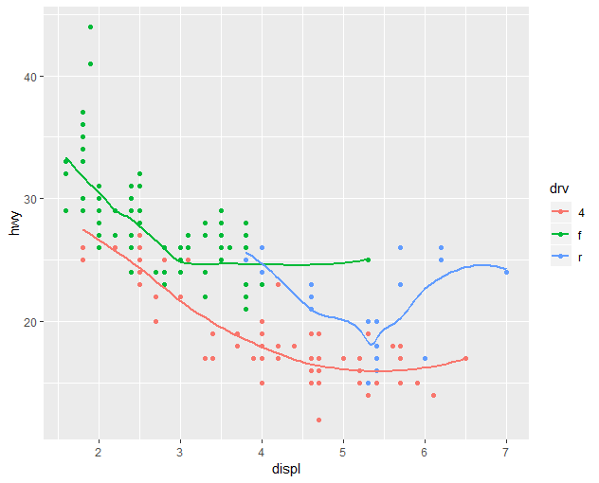

####question5

ggplot(data = mpg, mapping = aes(x = displ, y = hwy)) +

geom_point() +

geom_smooth()

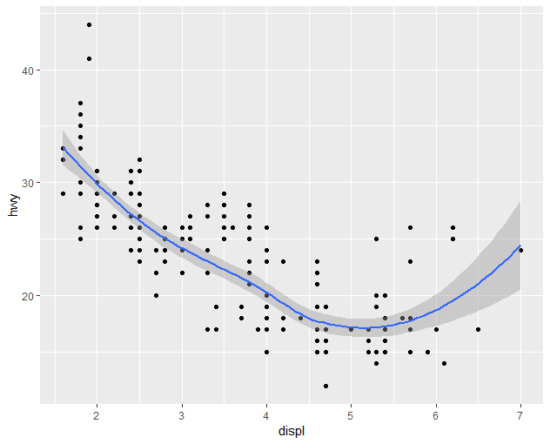

ggplot() +

geom_point(data = mpg, mapping = aes(x = displ, y = hwy)) +

geom_smooth(data = mpg, mapping = aes(x = displ, y = hwy))###no difference in this two graphs as the layers are the same



####question6

##graph1

ggplot(data = mpg, mapping = aes(x = displ, y = hwy)) +

geom_point() +

geom_smooth(se = FALSE)

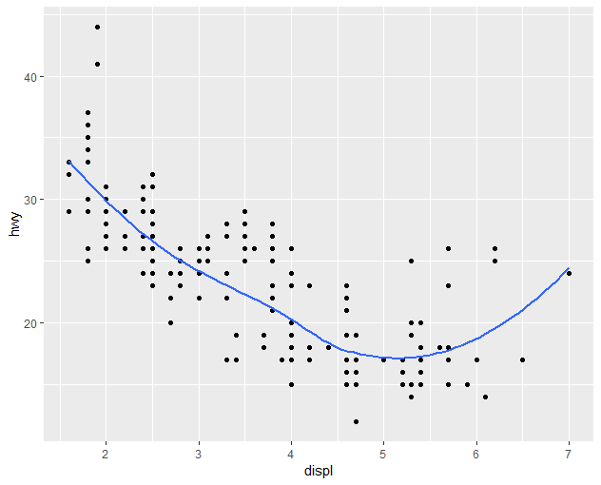

##graph2

ggplot(data = mpg, mapping = aes(x = displ, y = hwy)) +

geom_point() +

geom_smooth(mapping = aes(x = displ, y = hwy, group = drv), se = FALSE)

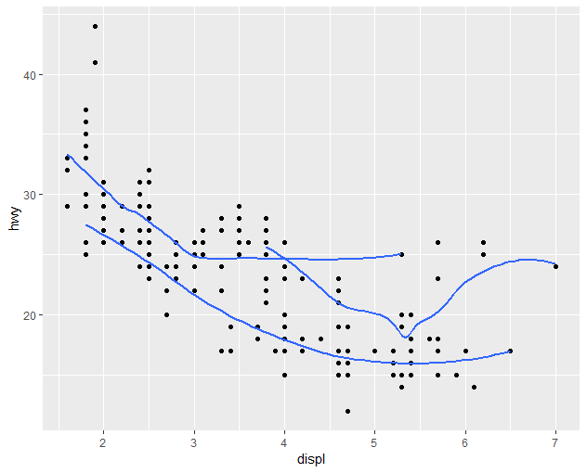

##graph3

ggplot(data = mpg, mapping = aes(x = displ, y = hwy, color = drv)) +

geom_point() +

geom_smooth()

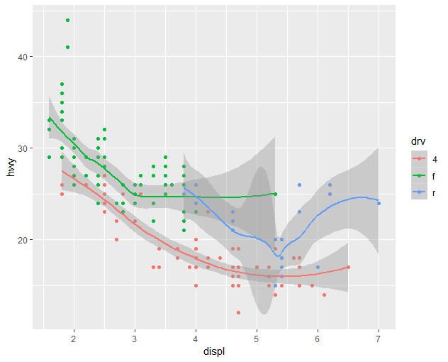

##graph4

ggplot(data = mpg, mapping = aes(x = displ, y = hwy)) +

geom_point(mapping = aes(color = drv)) +

geom_smooth(se = FALSE)

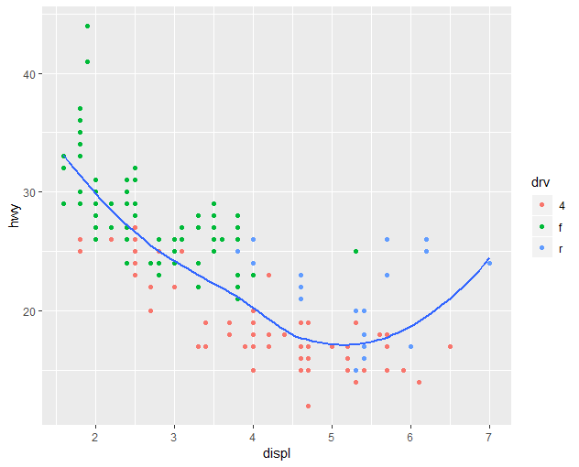

##graph5

ggplot(data = mpg, mapping = aes(x = displ, y = hwy)) +

geom_point(mapping = aes(color = drv)) +

geom_smooth(se = FALSE, mapping = aes(linetype = drv))

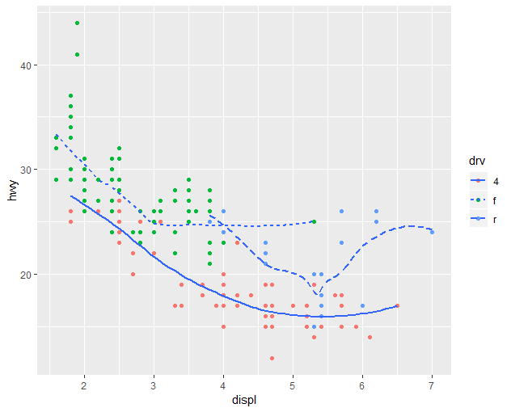

##graph6

ggplot(data = mpg, mapping = aes(x = displ, y = hwy)) +

geom_point(mapping = aes(color = drv)) +

geom_point(shape = 21, color = "white", stroke = 1)

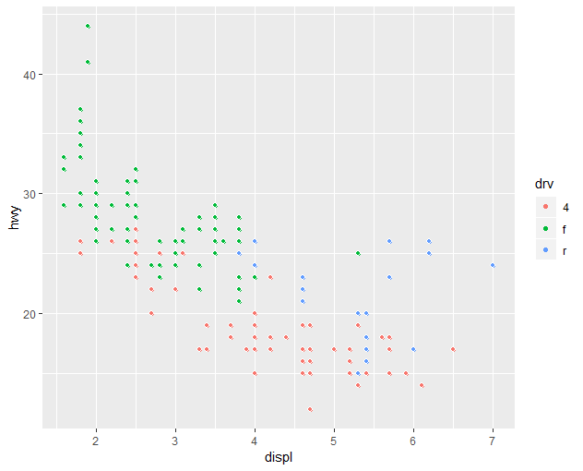

###COMBINING ALL GRAPHS TOGETHER

library(cowplot)

library(gridExtra)

p1 <- ggplot(data = mpg, mapping = aes(x = displ, y = hwy)) +

geom_point() +

geom_smooth(se = FALSE)

p2 <- ggplot(data = mpg, mapping = aes(x = displ, y = hwy)) +

geom_point() +

geom_smooth(mapping = aes(group = drv), se = FALSE)

p3 <- ggplot(data = mpg, mapping = aes(x = displ, y = hwy, color=drv)) +

geom_point() +

geom_smooth(se = FALSE)

p4 <- ggplot(data = mpg, mapping = aes(x = displ, y = hwy)) +

geom_point(mapping = aes(color=drv)) +

geom_smooth(se = FALSE)

p5 <- ggplot(data = mpg, mapping = aes(x = displ, y = hwy)) +

geom_point(mapping = aes(color=drv)) +

geom_smooth(se = FALSE, mapping = aes(linetype = drv))

p6 <- ggplot(data = mpg, mapping = aes(x = displ, y = hwy)) +

geom_point(mapping = aes(color=drv)) +

geom_point(shape = 21, color = "white", stroke = 1)

theme_set(theme_gray())

plot_grid(p1, p2, p3, p4, p5, p6, labels=c("1","2","3", "4","5","6"), ncol=2, nrow = 3)

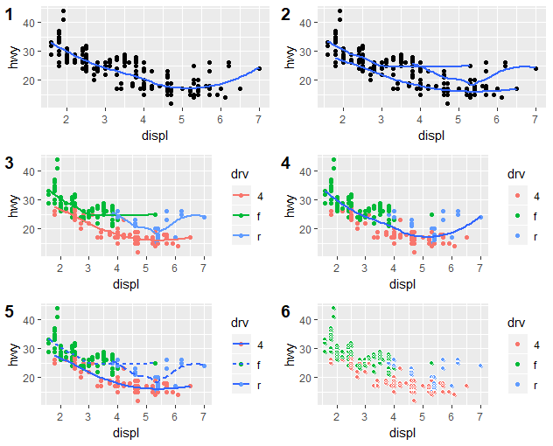

#3.7 STATISTICAL TRANSFORMATIONS

####3.7.1 Exercises

####Question1:default geom for stat_summary==geom_pointrange

####Question2:geom_col==it makes the heights of the bars representative of the values in the data, thus leaving the data as is

###geom_bar bins together the values and makes the heights of the bars a proportion of the total cases

ggplot(data = diamonds) +

geom_col(mapping = aes(x = cut, y = depth))

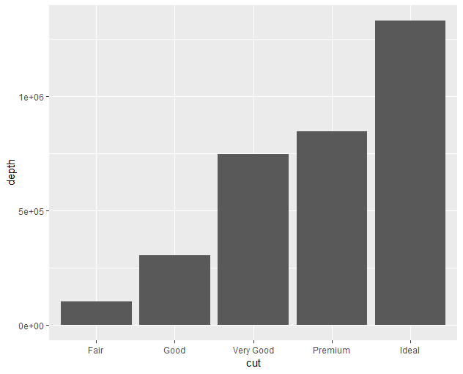

####Qusetion4:stat_smooth computes y:predicted value, ymin:lower C.I, ymax: upper C.I, se:standard error

####Question5: we set the group = 1 because if not, geom_bar assumes that all groups have equal x values

ggplot(data = diamonds) +

geom_bar(mapping = aes(x = cut, y = ..prop..))

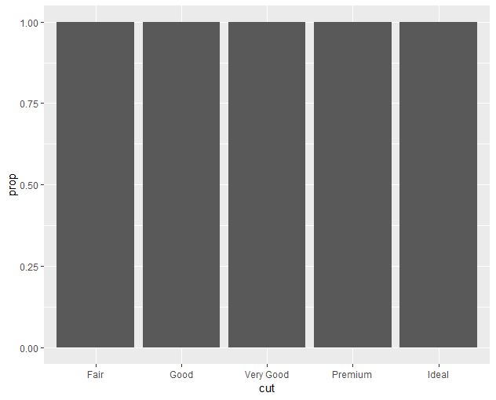

ggplot(data = diamonds) +

geom_bar(mapping = aes(x = cut, fill = color, y = ..prop..))

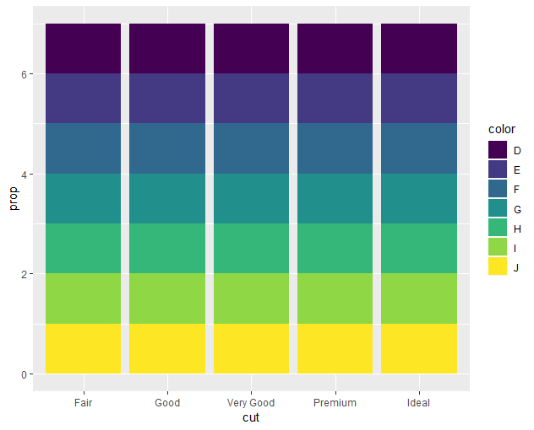

ggplot(data = diamonds) +

geom_bar(mapping = aes(x = cut, fill = clarity))

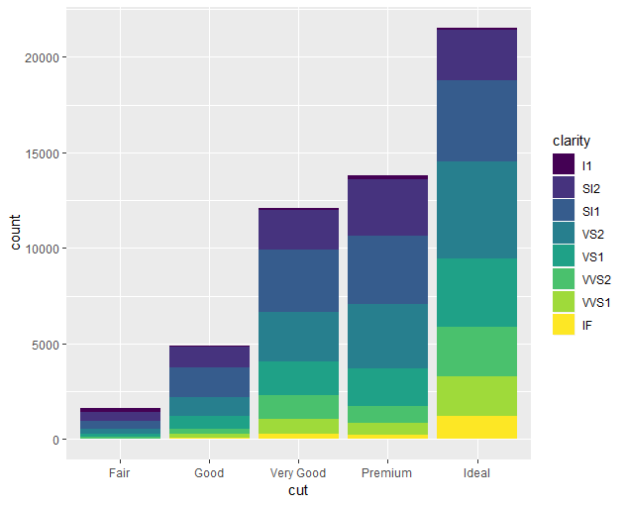

#3.8 POSITION ADJUSTMENTS

##3.8.1 Exercises

###Question 1 What is the problem with this plot? How could you improve it?

ggplot(data = mpg, mapping = aes(x = cty, y = hwy)) +

geom_point()

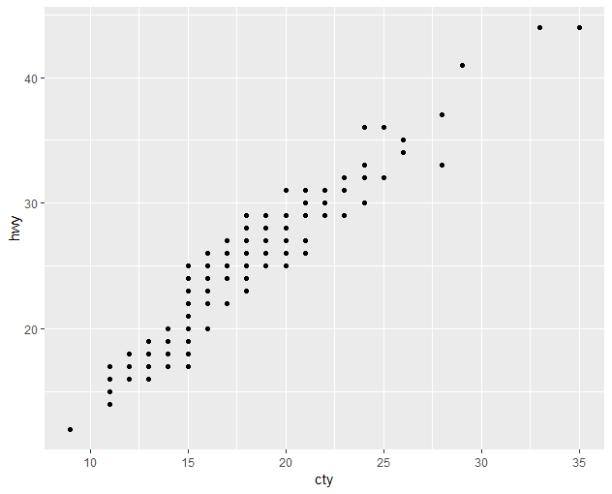

####Ans: Many of the points are not shown in the plot, as they overlap. This can be improved using geom_jitter

ggplot(data = mpg, mapping = aes(x = cty, y = hwy)) +

geom_jitter()

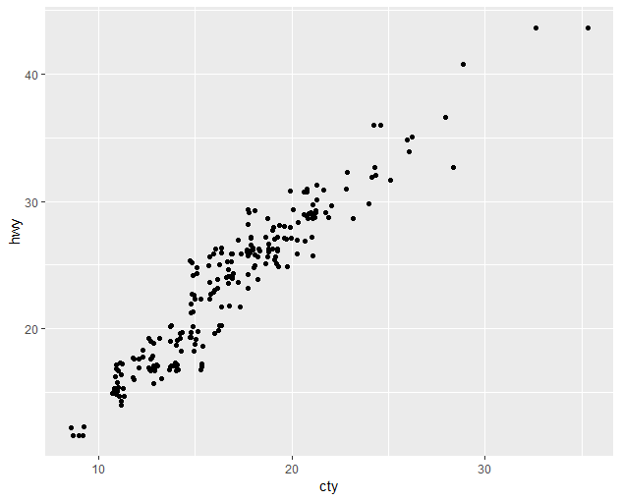

####Question 2 What parameters to geom_jitter() control the amount of jittering?

###Ans: The amount of jitter is controlled by increasing the distance between each of the points

####Qusetion 3 Compare and contrast geom_jitter() with geom_count().

###Ans:geom_count increases the size of overlapped points while geom_jitter allows one to see all points while keeping them the same size

####Question 4 What’s the default position adjustment for geom_boxplot()? Create a visualisation of the mpg dataset that demonstrates it.

##Ans: the default position is dodge

ggplot(data = mpg, mapping = aes(x = drv, y = hwy, color = class)) +

geom_boxplot(position="dodge")

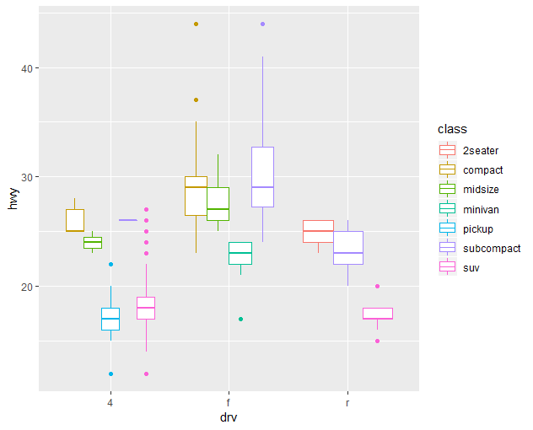

###we can also use identity

ggplot(data = mpg, mapping = aes(x = drv, y = hwy, color = class)) +

geom_boxplot(position="identity")

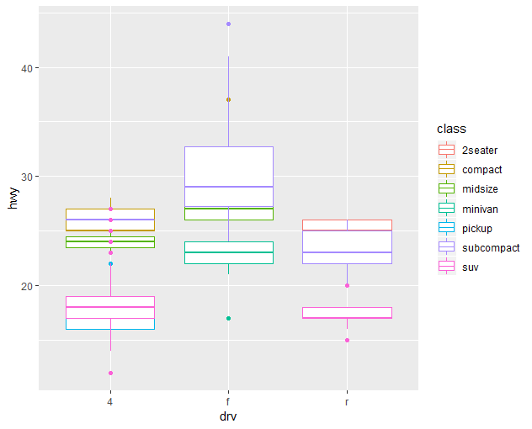

#3.9 COORDINATE SYSTEMS

####3.9.1 Exercises

###Question 1

ggplot(data = diamonds) +

geom_bar(mapping = aes(x = cut, fill = clarity), width = 1)

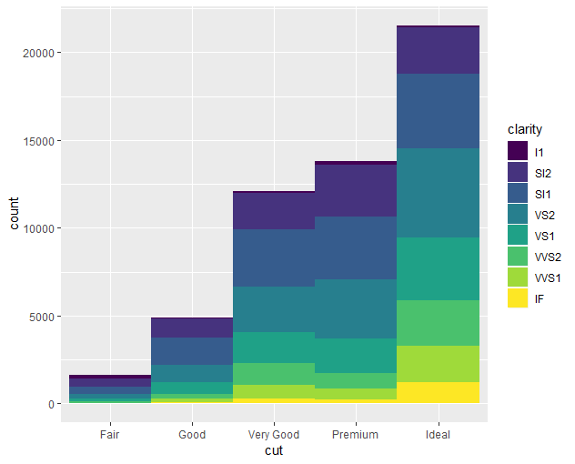

ggplot(data = diamonds) +

geom_bar(mapping = aes(x = cut, fill = clarity), width = 1) +

coord_polar()

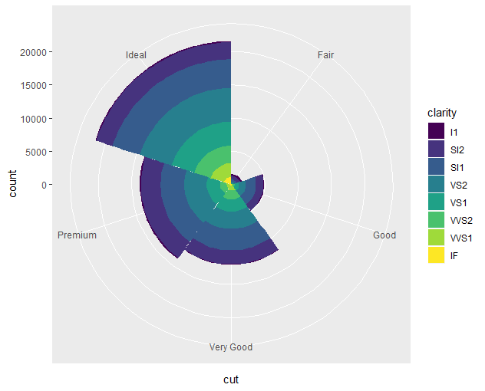

###Question 2 What does labs() do?

##Ans: It labels the coordinates by modifying axis, legends and plit tables

###Question 3What’s the difference between coord_quickmap() and coord_map()?

####Question 4 What does the plot below tell you about the relationship between city and highway mpg? Why is coord_fixed() important? What does geom_abline() do?

ggplot(data = mpg, mapping = aes(x = cty, y = hwy)) +

geom_point() +

geom_abline() +

coord_fixed()

